**Вопрос 2**

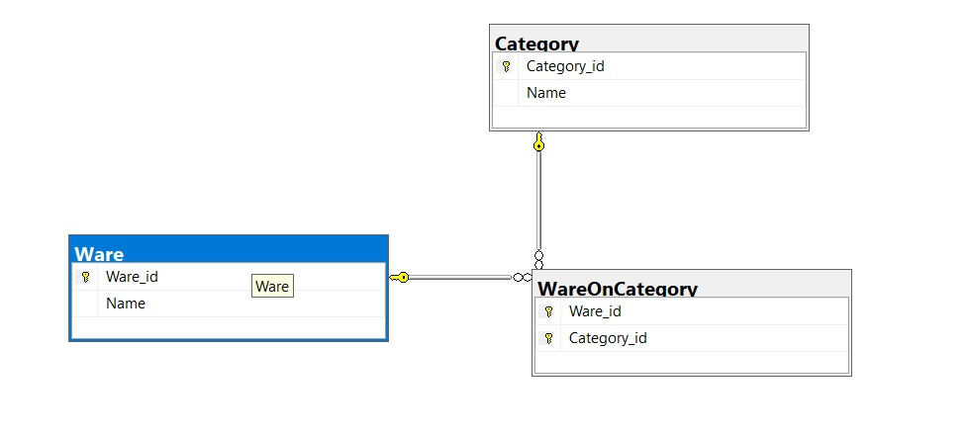

SELECT Ware.Name, Category.Name

FROM (Category

INNER JOIN WareOnCategory ON Category.Category_id = WareOnCategory.Category_id)

RIGHT JOIN Ware ON Ware.Ware_id = WareOnCategory.Ware_id